4. Website Planning and Design
4.1 Website Goals
The purpose of the IVY Technicals website is to provide a professional online platform that promotes the company's IT services and improves communication with customers. The website will provide users with detailed information about the company, allow them to enquire about services, and make it easier to contact the business.
The goals of the website are to:
- Promote IVY Technicals and its services.
- Increase the company's online visibility.
- Provide accurate information about the business.
- Allow customers to submit enquiries online.
- Build customer trust through a professional website.
- Improve customer communication and satisfaction.
5.2 Website Sitemap
The sitemap below shows the structure of the website and how the pages are connected.
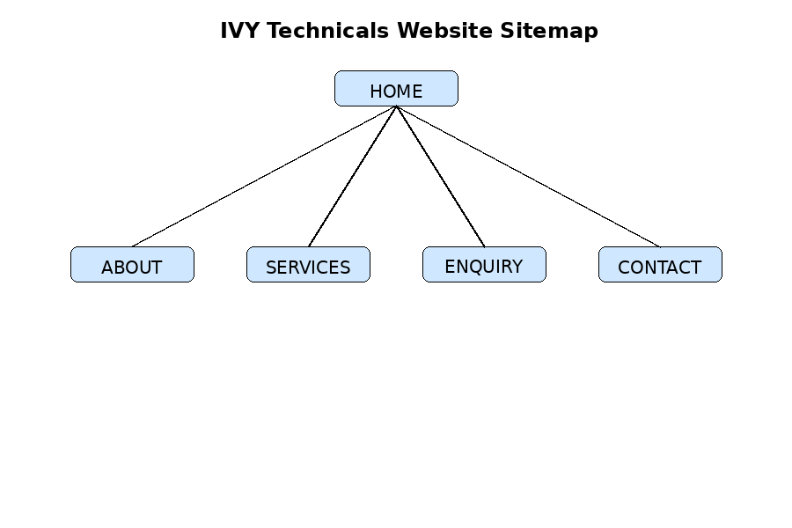
Website Navigation Structure
- Home
  - Welcome message
  - Company overview
  - Featured services
- About
  - Company background
  - Mission
  - Vision
  - Values
- Services
  - Laptop Repairs
  - Desktop Repairs
  - Networking
  - CCTV Installation
  - Software Installation
  - Technical Support
- Enquiry
  - Customer enquiry form
  - Name
  - Email
  - Phone Number
  - Message
- Contact
  - Business address
  - Email address
  - Telephone number
  - Business hours
5.3 Website Folder Structure
The website files will be organised as follows:
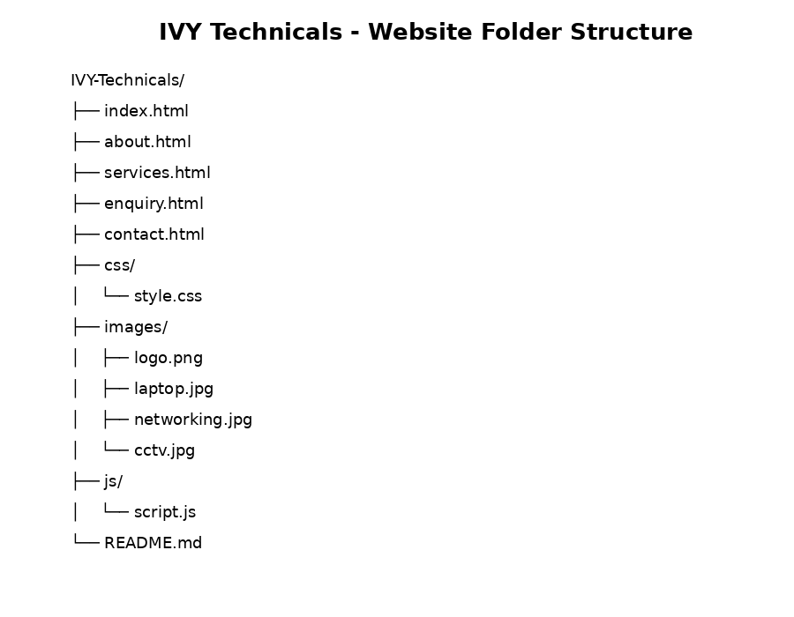
5.4 Wireframe
Homepage
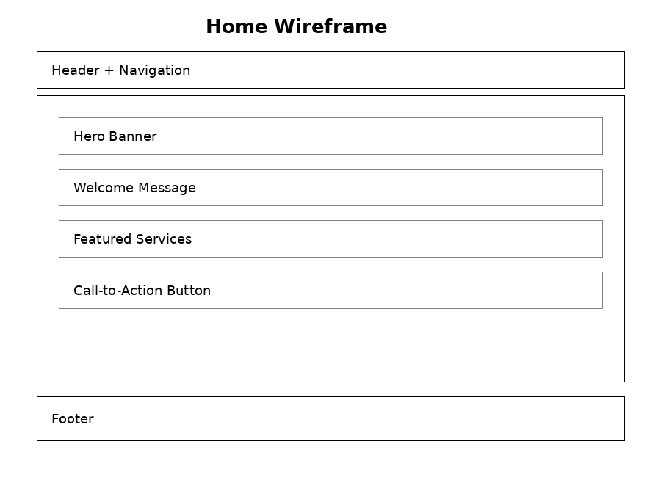
About Page
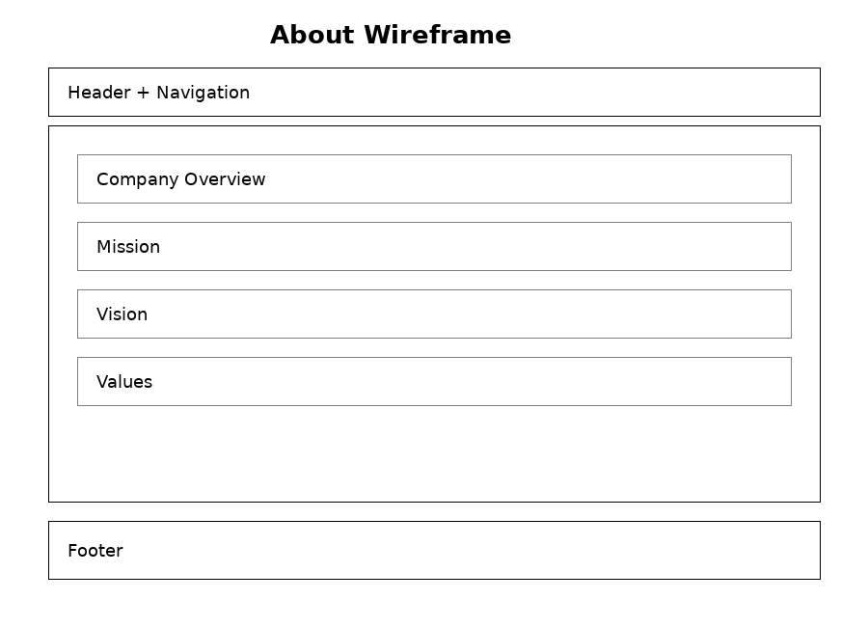
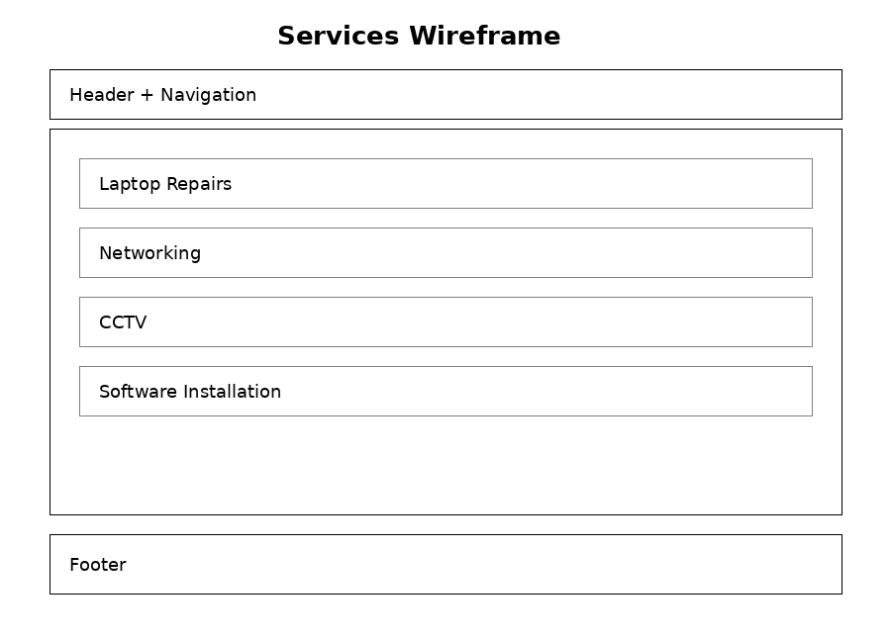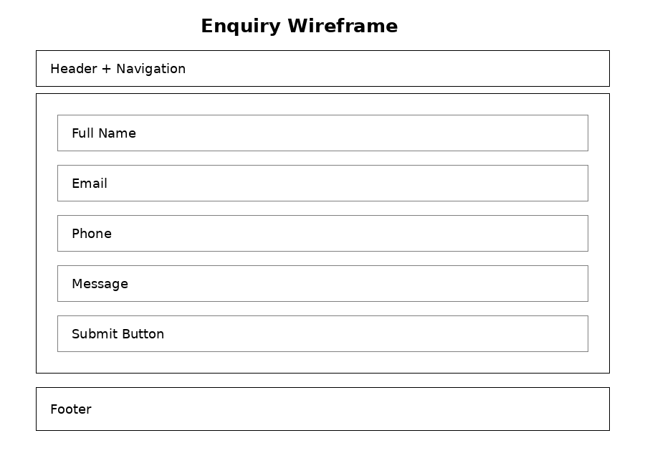
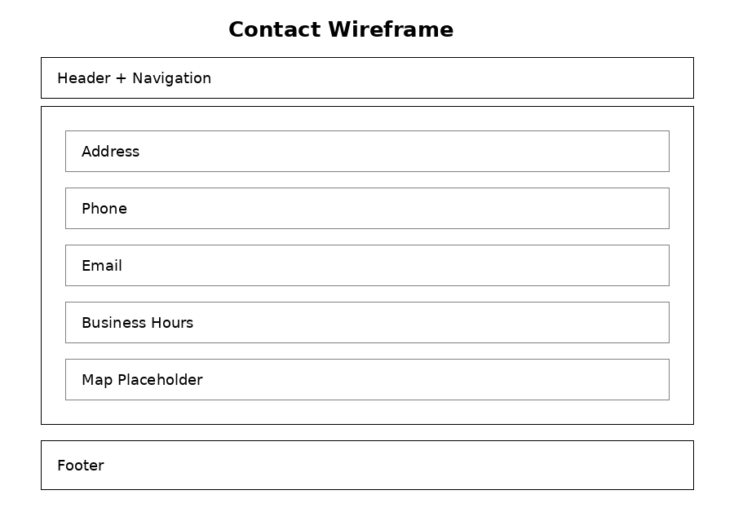
5.5 Navigation Structure
The website will use a consistent navigation menu displayed at the top of every page.
Navigation Menu
- Home
- About
- Services
- Enquiry
- Contact
This navigation system allows users to move between pages quickly without returning to the home page.
5.6 Design Justification
The website will follow modern web design principles to improve usability and accessibility.
Colour Scheme
- Blue – Represents trust, professionalism, and technology.
- White – Creates a clean and organised appearance.
- Black – Improves readability.
Typography
The website will use simple fonts such as Arial or Calibri because they are easy to read on desktop and mobile devices.
Layout
The layout will:
- Be simple and uncluttered.
- Use headings to organise content.
- Include adequate spacing between sections.
- Be responsive for mobile, tablet, and desktop devices.
Accessibility
The website will include:
- Easy-to-read text.
- Consistent navigation.
- Clear headings.
- Proper colour contrast.
- Responsive design.

5.7 Conclusion
The planning and design stage provides a clear structure for the IVY Technicals website. The sitemap, folder structure, wireframes, and navigation plan ensure that the website will be organised, user-friendly, and easy to maintain. These planning documents will guide the implementation of the website during the development phase and help ensure that the final product meets the needs of both the organisation and its users.

